HotPot

Problem statement:
A popular restaurant chain sought to capitalize on the growing trend of online food ordering by developing a state-of-the-art full stack web application. The goal was to provide customers with a
seamless and user-friendly platform for ordering food online, enhancing their overall dining experience.

Scope
- User Registration and Authentication: Allow users to register, log in, and securely manage their accounts.
- Menu Management: Restaurant staff/admin manage menu listings, track menu, and update menu availability. menu with detailed item descriptions, prices, and images. Implement menu categorization for breakfast, lunch, and dinner, Appetizer, Main Course, Dessert, burger, pizza, Italian, Arabian etc items.
- Efficient Order Placement: Develop user-friendly interface for customers to place food orders efficiently and should be notified by email.
- Cart Management: Enable users to add, remove, and manage items in their carts before checkout.
- Order Tracking and Notifications: Integrate real-time order tracking [order confirmations, dispatch, and estimated delivery times] to keep customers informed about the status of their orders through email.
- Restaurant Management: Restaurant can add menu and fix the discount price for the menu. Restaurant can view the orders, update the order status.

Technologies:
  - Frontend: Html,CSS,Bootstrap,SASS,JSP,Spring Thymeleaf
- Backend: Java, Spring Boot with Hibernate/ DATA JPA for API development.
- Database: MySql .
- Authentication: JSON Web Tokens (JWT) for secure user authentication.
Reference Link: https://www.swiggy.com/

Use case Diagram:
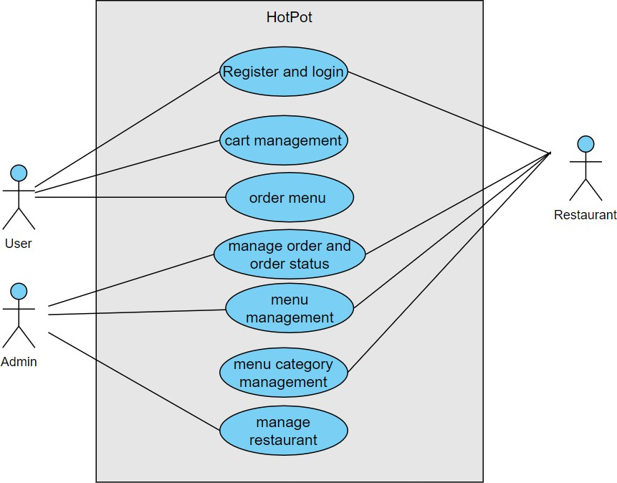

Use Cases:
Actor: User
  - Use Case: User Registration and login.
  - Use Case: Menu Browsing.
  - Use Case: Cart Management.
  - Use Case: Checkout and Payment.
  - Use Case: View orders history.

Actor: Restaurant
  - Use Case: Login as Restaurant Management.
  - Use Case: Menu Management.
  - Use Case: Order Processing.
  - Use Case: view orders and menu.

Actor: Administrator
  - Use Case: Log In.
  - Use Case: Add / Remove Restaurant.

  - Use Case: view all menu, restaurant, and orders.

System: Security and Authentication
  - Use Case: Authenticate User

System: Database Management
  - Use Case: Store Menu Information
  - Use Case: Store Order Information
  - Use Case: Store User and Restaurant Data

Development Process:
- User and Restaurant Registration / Login:
  - Users can create accounts, providing personal details (name, gender, contact number, email, address, etc.)
  - Admin can create restaurant accounts by providing restaurant information (restaurant name, location, contact number)
  - The system validates the information and creates user, restaurant profiles.
  - Users and restaurant log in using their credentials (username/email and password).

User's Dashboard:
  - Users can browse menu and view detailed descriptions (menu ingredients), images, and prices, discounts.
  - Users navigate through menu categories (such as breakfast, lunch, and dinner, burger, pizza, Italian, Arabian) or search for specific items.
    - Include filters for categories, Veg, Nonveg and price ranges.
    - Implement a search feature with auto-suggestions and predictive text.
    - Clicking on menu item from menu list to view more information about a menu. Menu details, images, pricing, and restaurant name, ingredients, cooking time are displayed.
  - Users can add products to their shopping carts for purchase.
    - Users click an "Add to Cart" button on the product page.
    - The selected menu is added to their shopping cart.

User's and Cart Management:
      - Users can view and manage items in their shopping carts, including adding, removing, or updating quantities of menu in cart.
        - Calculate and display the total order cost.

        - Enable customers to review and edit their cart before placing an order.
        - They can remove items, update quantities, or proceed to checkout.
        - Users click the "Checkout" button from their shopping cart to initiate placing order.
        - They provide shipping details and select a payment method.
        - Payment information is securely processed.

Restaurant Dashboard:
      - Restaurant can create new menu, new category and edit, or delete existing ones, and mark menu as out of stock.
      - Restaurant can add menu with following details {Item Name, Description (including key ingredients), Category name, Price, Availability Time (e.g., all day, breakfast hours, lunch hours), Special Dietary Information(Veg, Nonveg), TasteInfo (Sweet, spicy light, spicy full, etc), Nutritional Info (Provide details on nutritional content, including calories, fats, proteins, and carbohydrates)}.
      - Restaurant can manage their order through orders dashboard. They can view the status of orders, including processing and delivery updates.
      - The Restaurant can view history of orders of their menu.

Administrators Dashboard
      - Administrators can manage (add, delete) user accounts and Restaurant accounts.
      - Admins can add, modify, or remove menu for the restaurant menu and categories.

Security and Compliance:
      - User authentication and authorization are enforced to ensure data privacy.

JWT Authentication:
JWT authentication involves generating a token upon successful user login and sending it to the client. The client includes this token in subsequent requests to authenticate the user.
  - User Login: Upon successful login (using valid credentials), generate a JWT token on the server.
  - Token Payload: The token typically contains user-related information (e.g., user ID, roles, expiration time).
  - Token Signing: Sign the token using a secret key known only to the server. This ensures that the token hasn't been tampered with.
  - Token Transmission: Send the signed token back to the client as a response to the login request.

  - Client Storage: Store the token securely on the client side (e.g., in browser storage or cookies).

JWT Authorization:
JWT authorization involves checking the token on protected routes to ensure that the user has the required permissions.
  - Protected Routes: Define routes that require authentication and authorization.
  - Token Verification:
    - Extract the token from the request header.
    - Verify the token's signature using the server's secret key.
  - Payload Verification:
    - Decode the token and extract user information.
    - Check user roles or permissions to determine access rights.
  - Access Control: Grant or deny access based on the user's roles and permissions.

Logout:
  - Logging out involves invalidating the JWT token on both the client and the server to prevent further unauthorized requests.

Project Development Guidelines
The project to be developed based on the below design considerations.

1 | Backend Development | - Use Rest APIs (Springboot/ASP. WebAPI to develop the services  - Use Java/C# latest features  - Use ORM with database  - perform backend data validation  - Use Swagger to invoke APIs  - Implement API Versioning  - Implement security to allow/disallow CRUD operations  - Message input/output format should be in JSON (Read the values from the property/input files, wherever applicable). Input/output format can be designed as per the discretion of the participant.  - Any error message or exception should be logged and should be user-readable (not technical)  - Database connections and web service URLs should be configurable  - Implement Unit Test Project for testing the API  - Implement JWT for Security  - Implement Logging

- Follow Coding Standards with proper project structure.

Frontend Constraints

1. | Layout and Structure | Create a clean and organized layout for your registration and login pages. You can use a responsive grid system (e.g., Bootstrap or  Flexbox) to ensure your design looks good on various screen sizes.
2 | Visual Elements | Logo: Place your application's logo at the top of the page to establish  brand identity.
Form Fields: Include input fields for email/username and password for both registration and login. For registration, include additional
fields like name and possibly a password confirmation field.
Buttons: Design attractive and easily distinguishable buttons for
"Register," "Login," and "Forgot Password" (if applicable).
Error Messages: Provide clear error messages for incorrect login
attempts or registration errors.
Background Image: Consider using a relevant background image to
add visual appeal.
Hover Effects: Change the appearance of buttons and links when
users hover over them.
 |  | Focus Styles: Apply focus styles to form fields when they are selected
3. | Color Scheme and Typography | Choose a color scheme that reflects your brand and creates a visually pleasing experience. Ensure good contrast between text and  background colors for readability. Select a legible and consistent typography for headings and body text.
4. | Registration Page, add product page by  seller, add shipping address page by user | Form Fields: Include fields for users to enter their name, email,  password, and any other relevant information. Use placeholders and labels to guide users.
Validation: Implement real-time validation for fields (e.g., check email format) and provide immediate feedback for any errors.
Form Validation: Implement client-side form validation to ensure required fields are filled out correctly before submission.
 | Registration Page | Password Strength: Provide real-time feedback on password strength using indicators or text.  Password Requirements: Clearly indicate password requirements  (e.g., minimum length, special characters) to help users create strong passwords.
Registration Success: Upon successful registration, redirect users to
the login page.
5. | Login Page | Form Fields: Provide fields for users to enter their email and  password.
Password Recovery: Include a "Forgot Password?" link that allows
users to reset their password.
6. | Common to UI Development | - Use JSP/ Spring Thymeleaf develop the UI.  - Implement Forms, databinding, validations, error message in required pages.  - Implement Routing and navigations.

Frontend Constraints

1. | Layout and Structure | Create a clean and organized layout for your registration and login  pages. You can use a responsive grid system (e.g., Bootstrap or Flexbox) to ensure your design looks good on various screen sizes.
2 | Visual Elements | Logo: Place your application's logo at the top of the page to establish  brand identity.
Form Fields: Include input fields for email/username and password for both registration and login. For registration, include additional
fields like name and possibly a password confirmation field.
Buttons: Design attractive and easily distinguishable buttons for
"Register," "Login," and "Forgot Password" (if applicable).
Error Messages: Provide clear error messages for incorrect login
attempts or registration errors.
Background Image: Consider using a relevant background image to
add visual appeal.
Hover Effects: Change the appearance of buttons and links when
users hover over them.
 |  | Focus Styles: Apply focus styles to form fields when they are selected
3. | Color Scheme and Typography | Choose a color scheme that reflects your brand and creates a visually pleasing experience. Ensure good contrast between text and  background colors for readability. Select a legible and consistent typography for headings and body text.
4. | Registration Page, add product page by  seller, add shipping address page by user | Form Fields: Include fields for users to enter their name, email,  password, and any other relevant information. Use placeholders and labels to guide users.
Validation: Implement real-time validation for fields (e.g., check email format) and provide immediate feedback for any errors.
Form Validation: Implement client-side form validation to ensure required fields are filled out correctly before submission.
 | Registration Page | Password Strength: Provide real-time feedback on password strength using indicators or text.  Password Requirements: Clearly indicate password requirements  (e.g., minimum length, special characters) to help users create strong passwords.
Registration Success: Upon successful registration, redirect users to
the login page.
5. | Login Page | Form Fields: Provide fields for users to enter their email and  password.
Password Recovery: Include a "Forgot Password?" link that allows
users to reset their password.
6. | Common to UI Development | - Use JSP/ Spring Thymeleaf develop the UI.  - Implement Forms, databinding, validations, error message in required pages.  - Implement Routing and navigations.

